**TCP/ IP model:**

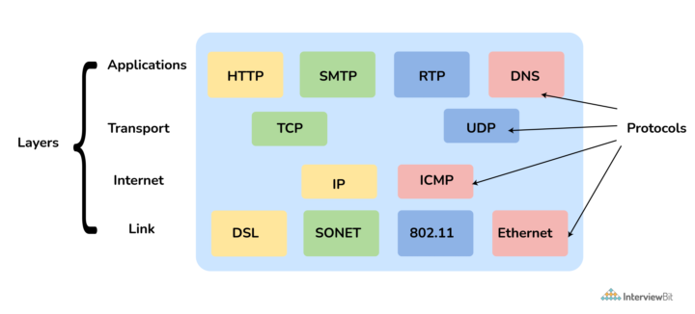

**OSI model:**

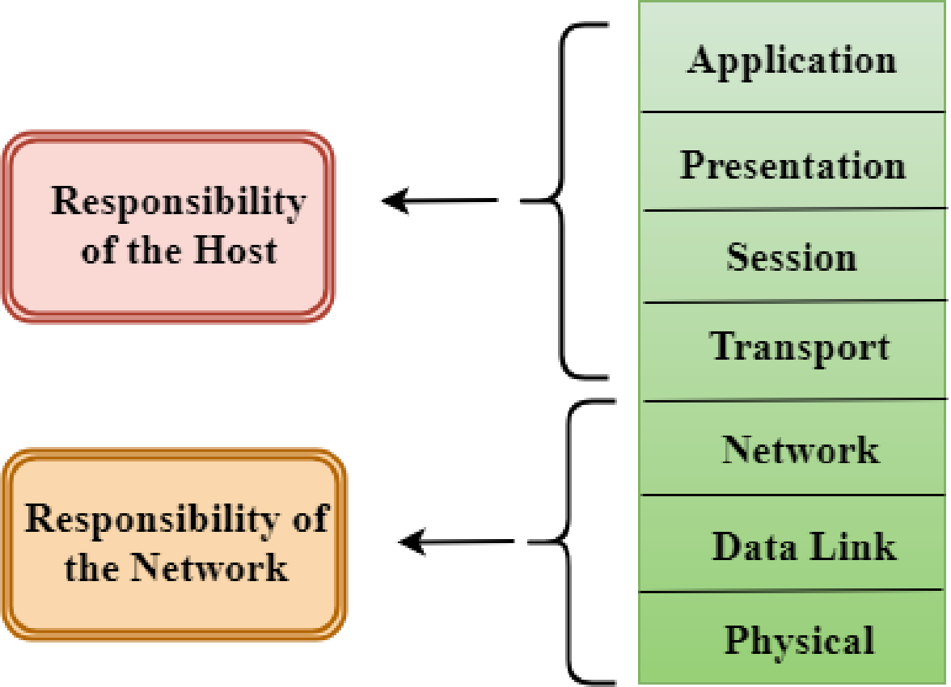

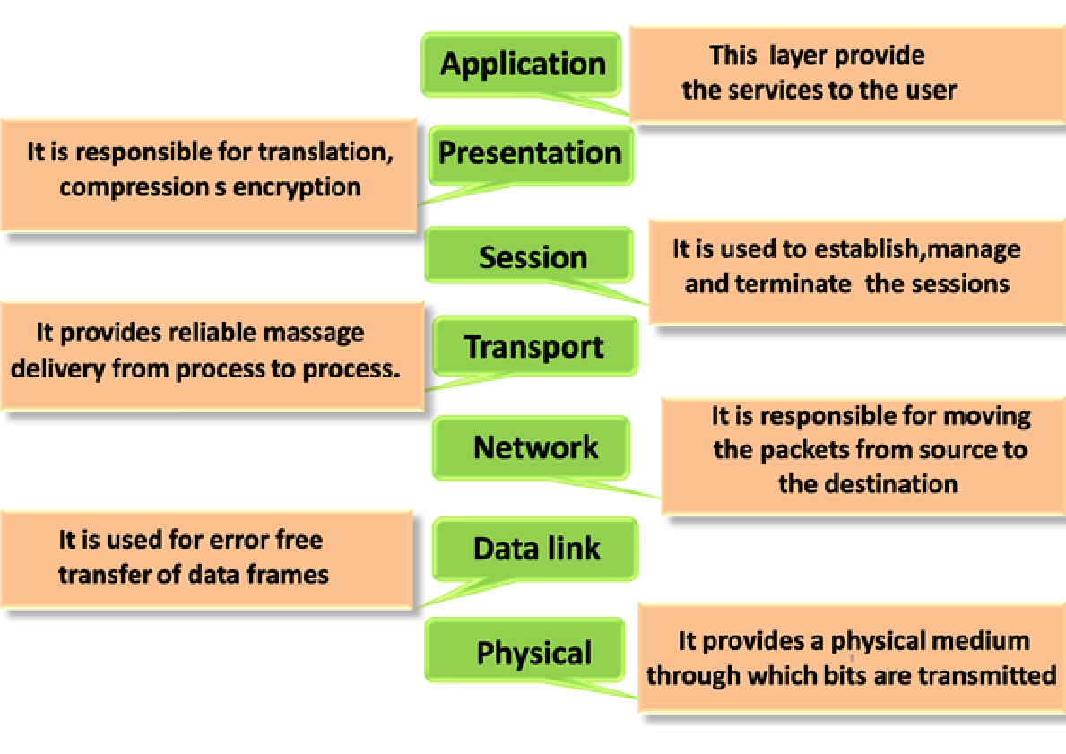

**TCP and UDP:**

Transmission Control Protocol (TCP) is connection-oriented, meaning once a connection has been established, data can be transmitted in two directions. TCP has built-in systems to check for errors and to guarantee data will be delivered in the order it was sent, making it the perfect protocol for transferring information like still images, data files, and web pages

User Datagram Protocol (UDP) is a simpler, connectionless Internet protocol wherein error-checking and recovery services are not required. With UDP, there is no overhead for opening a connection, maintaining a connection, or terminating a connection; data is continuously sent to the recipient, whether or not they receive it.

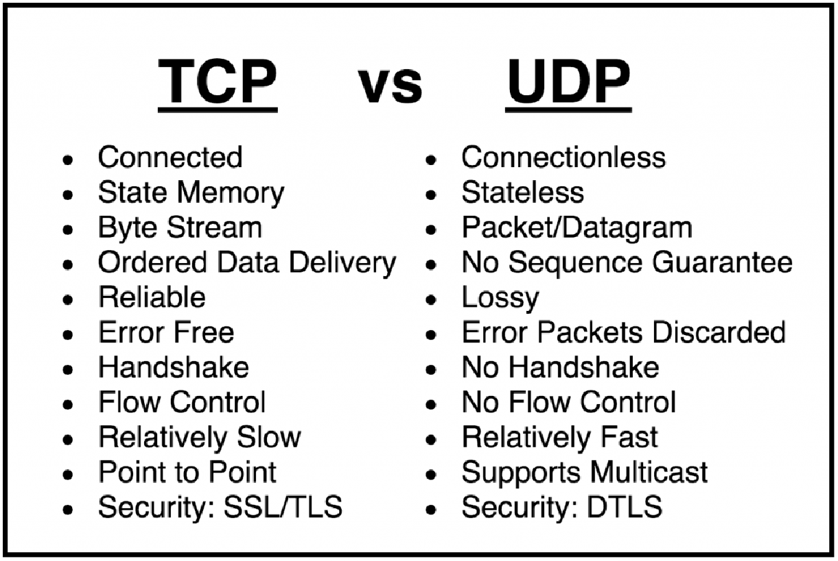

**IPV4 and IPV6:**

An IP stands for internet protocol. An IP address is assigned to each device connected to a network.

IPv4 is a version 4 of IP. It is a current version and the most commonly used IP address. It is a 32-bit address written in four numbers separated by 'dot', i.e., periods. This address is unique for each device. For example, 66.94.29.13 ,Each number in an octet is in the range from 0-255. This address can produce 4,294,967,296 possible unique addresses(and the world population is 7.6 Billion that's disadvantage)

IPv6 is a 128-bit hexadecimal address.

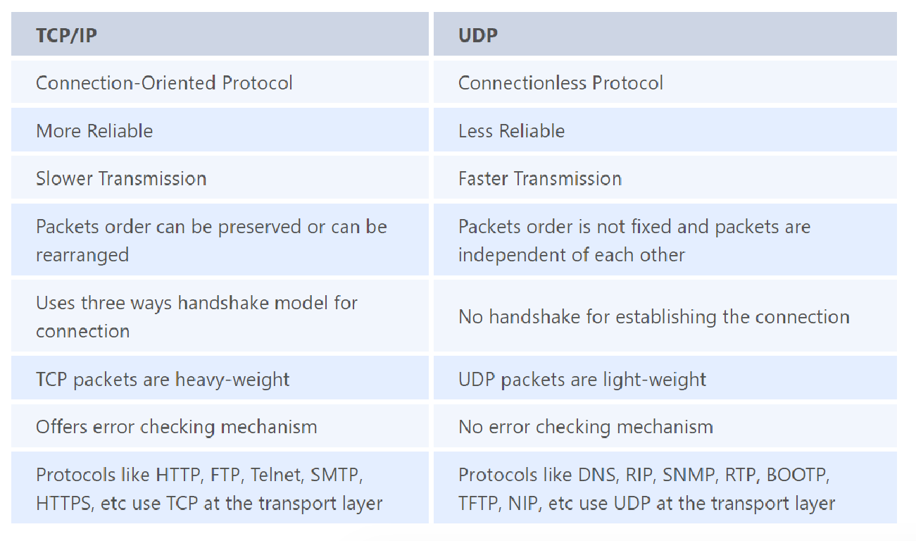

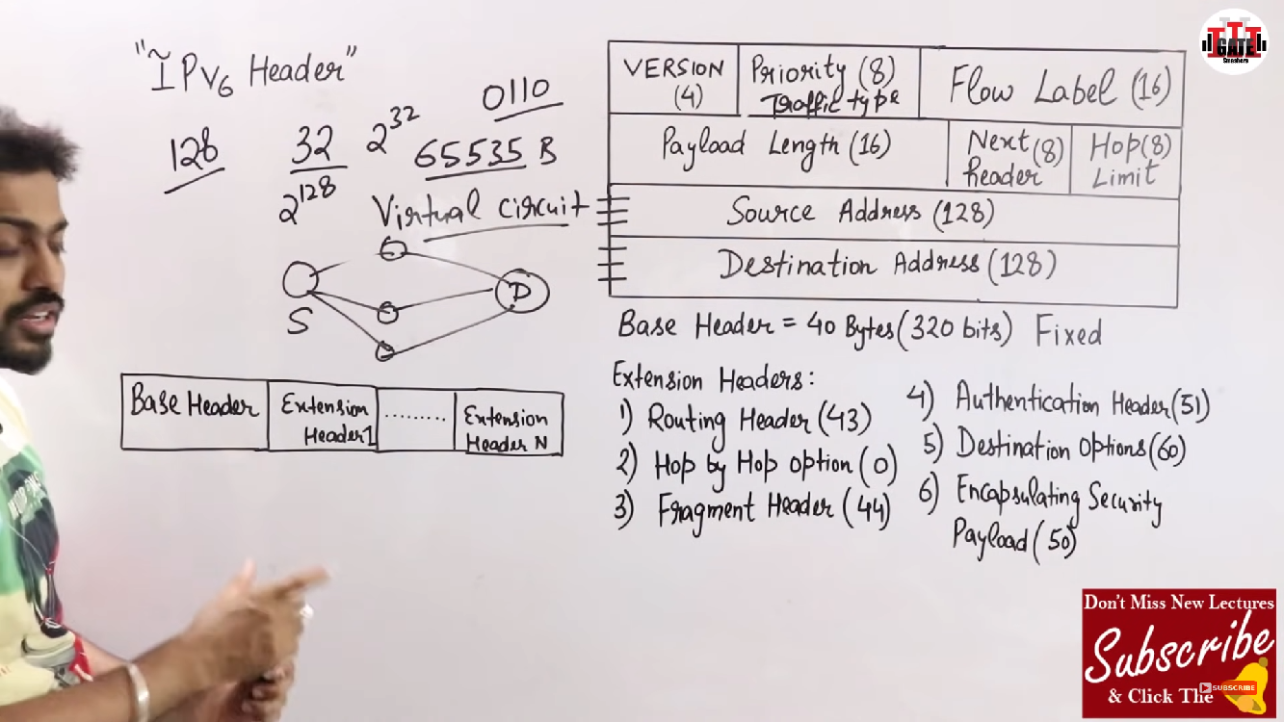

**User Datagram Protocol (UDP):**

User Datagram Protocol (UDP) is a communications protocol that is primarily used to establish low-latency and loss-tolerating connections between applications on the internet. UDP speeds up transmissions by enabling the transfer of data before an agreement is provided by the receiving party.

User Datagram Protocol (UDP) is a Transport Layer protocol. it is an unreliable and connectionless protocol.

User Datagram Protocol (UDP) is more efficient in terms of both latency and bandwidth.

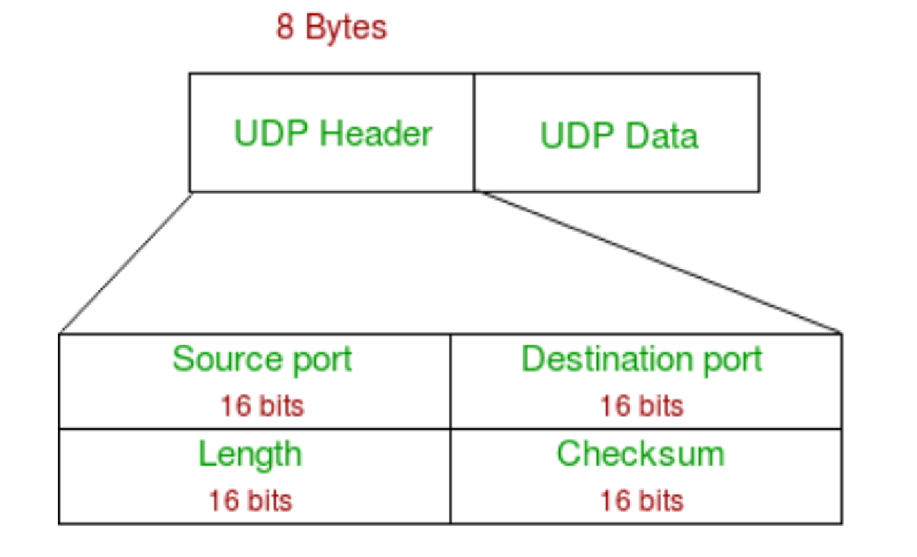

TCP vs UDP:

TCP communication involves a process known as a “handshake,” which establishes the connection. In addition, only when it is completed the transfer of data packets could happen.

On the other hand, the UDP connection is not including this “handshake” process which means one device simply starts sending the information to the receiving one. Additionally, UDP communications do not include details about the order or confirmation for the arrival of the data. It is exactly the opposite when it comes to TCP.

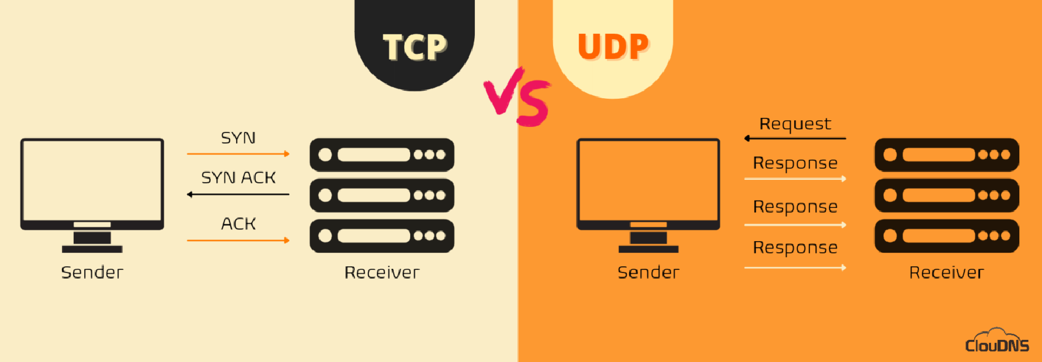

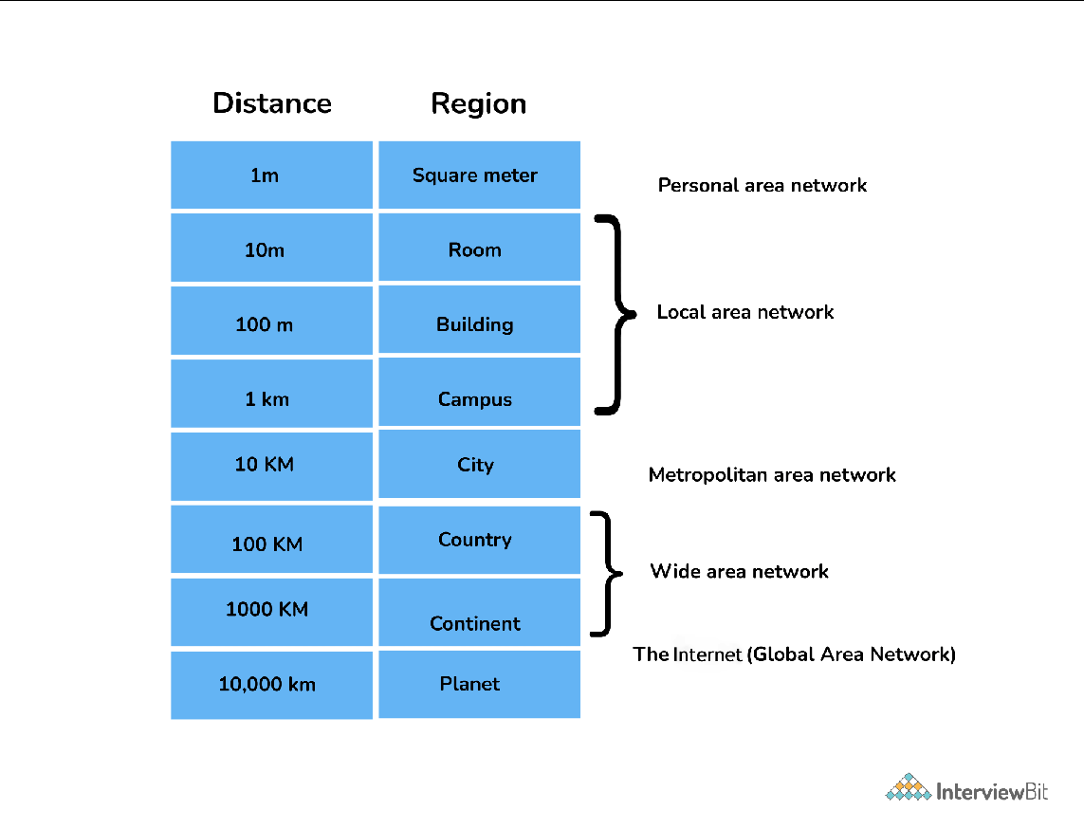

**Different types of Topologies:**

Bus Topology:

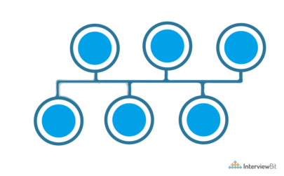

Star Topology:

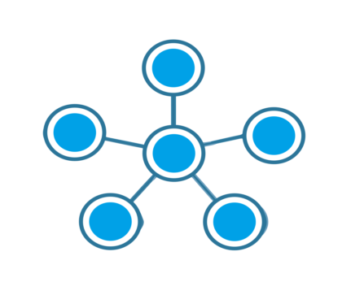

Ring Topology:

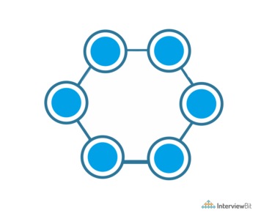

Mesh topology

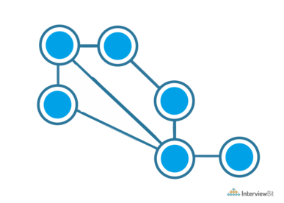

Tree topology

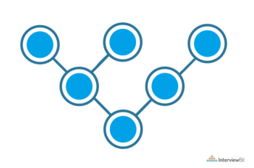

Hybrid topology:

It is a combination of different topologies to form a new topology.

It helps to ignore the drawback of a particular topology and helps to pick the strengths from others.

**Extra Information:**

DNS translates the domain names to their corresponding IPs.

SMTP is the Simple Mail Transfer Protocol. SMTP sets the rule for communication between servers.

FTP is a File Transfer Protocol. It is an application layer protocol used to transfer files and data reliably and efficiently between hosts. (default port 27).

MAC address is the Media Access Control address. It is a 48-bit or 64-bit unique identifier of devices in the network. It is also called the physical address embedded with Network Interface Card (NIC) used at the Data Link Layer. NIC is a hardware component in the networking device using which a device can connect to the network.

**Subnet:**

